FOSTER HOME AGREEMENT 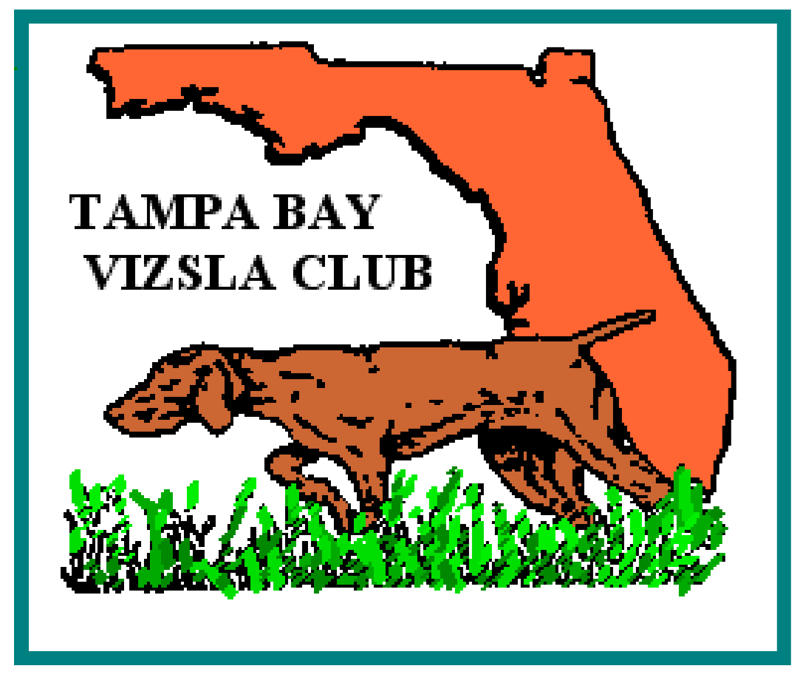

I, _________________________________________, the undersigned Foster Home agree to all conditions set forth in this Foster Home Agreement, established by the Tampa Bay Vizsla Club Rescue (“TBVC Rescue”):

This agreement will be effective as of this _____________day of _______________, ___________and will continue until TBVC finds a foster to adopt home for the dog.

This foster home covers the fostering of a ( ) Male ( ) Female vizsla identified by the name of: _________________________________________.

- The foster home agrees that the dog will live in the foster’s home as a member of the family. Having been advised that the Vizsla breed is active and requires a lot of exercise, the foster home agrees to provide the dog with adequate exercise, either in a fenced yard, on a lead or in another safe area.

2. In the case of a dog that needs extra medical care, the foster home agrees to give all the necessary care to the dog,

3. Because the vizsla is not suited to be kept as a permanent yard-only dog, the foster home agrees not to isolate this dog away from his/her family. Further, it is agreed that the dog will not be tied or chained except as a temporary safety measure.

4. This dog will be identified at all times with either an identification tag, license tag, rabies tag with Veterinarian Name and Inoculation Number, or tattoo or micro-chip which is registered with a national agency.

5. This dog may not be transferred to any person, organization, firm, or corporation without the express written consent of the Chair of TBVC Rescue.

6. As a foster home you must agree to work closely and communicate with the TBVC Rescue Chair about how the rescue is doing. Any medical need will be discussed with the TBVC Rescue Coordinator before obtaining unless it is an emergency situation. All bills required while dog is in your care are to be passed through the Rescue Chair and then submitted to the TBVC Treasurer. Only bills that are within reason as decided by the Rescue Chair will be reimbursed.

7. The dog will be provided adequate food, water, and proper shelter from the elements at all times.

8. The foster home agrees to obey any and all animal control laws, rules, and regulations as may be applicable in the area in which he/she resides.

9. The foster home agrees to hold harmless TBVC Rescue, the Tampa Bay Vizsla Club, (“TBVC”) its members, volunteers, agents, officers, their heirs and assignees for any problems with the dog or its actions.

10. If the dog is lost or suspected stolen, the Adopter will notify TBVC Rescue immediately. The Adopter agrees to make every good faith effort to locate the dog, including social media, making posters and to notify local veterinarians and animal control authorities.

11. Because this is a rescue dog, the foster understands and agrees that the TBVC Rescue cannot and does not warrantee or guarantee the health, disposition, temperament, character, or suitability of the dog. Further, the suitability of the dog to any specific tasks, purposes, or circumstances is not assured.

12. The foster home will evaluate the dog and will report regularly to the rescue coordinator. This evaluation will help find a prospective family.

I (We) have read this agreement and hereby agree to abide by all conditions set forth therein.

Foster home
Signed:
Print name:
Date:

Name, Address and Telephone Number of Adopter:

Tampa Bay Vizsla Club Rescue
Signed:
Date:

Form: January 2022

