FOSTER TO ADOPT AGREEMENT 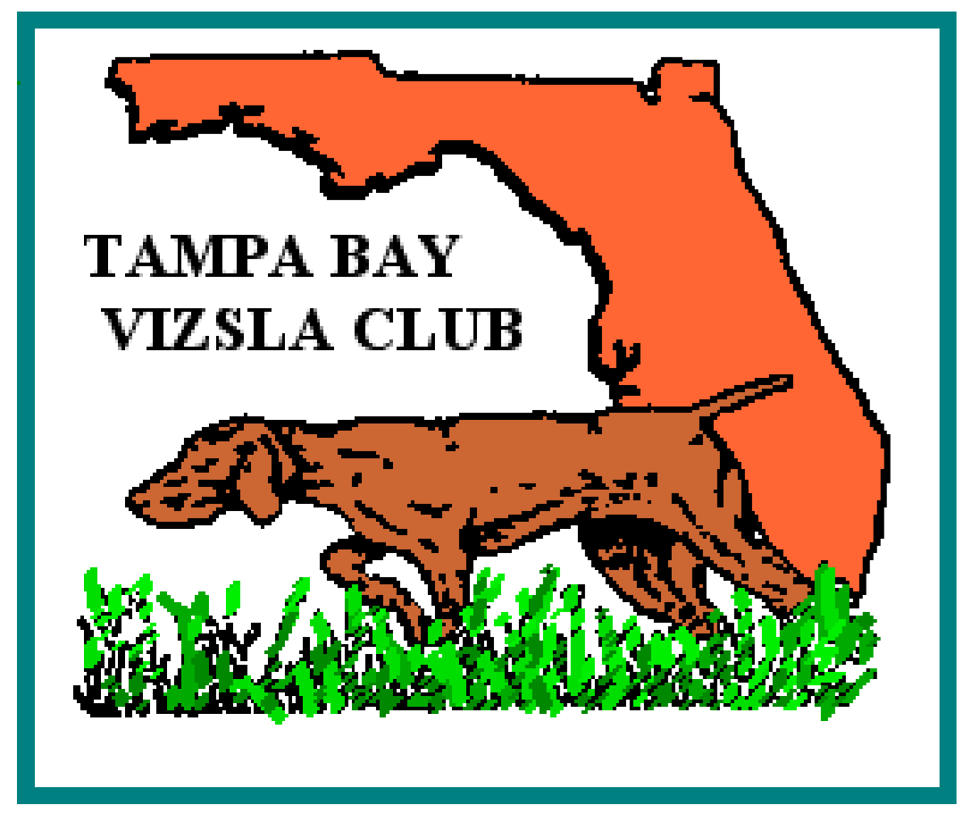

I, _________________________________________, the undersigned Foster (the “foster to adopt”) agree to all conditions set forth in this Foster to Adopt Agreement, established by the Tampa Bay Vizsla Club Rescue (“TBVC Rescue”):

This agreement will be effective as of this _____________day of _______________, ___________and will continue for 30 days, or until the adoption agreement is signed.

This foster to adopt covers the adoption of a ( ) Male ( ) Female vizsla identified by the name of: _________________________________________.

1. The dog will be given a three to four weeks adjustment period in consideration of the fact that it takes a minimum of this amount of time for the dog to adjust to new humans and surroundings. After the trial period, the adopter will be asked to give a donation of $250 to Tampa Bay Vizsla Club Rescue.

2. The foster agrees that the dog will live in the foster’s home as a member of the family. Having been advised that the Vizsla breed is active and requires a lot of exercise, the Adopter agrees to provide the dog with adequate exercise, either in a fenced yard, on a lead or in another safe area.

3. Because the vizsla is not suited to be kept as a permanent yard-only dog, the foster agrees not to isolate this dog away from his/her family. Further, it is agreed that the dog will not be tied or chained except as a temporary safety measure.

4. This dog will be identified at all times with either an identification tag, license tag, rabies tag with Veterinarian Name and Inoculation Number, or tattoo or micro-chip which is registered with a national agency.

5. This dog may not be transferred to any person, organization, firm, or corporation without the express written consent of the Chair of TBVC Rescue.

6. As a foster you must agree to work closely and communicate with the TBVC Rescue Chair about how the rescue is doing. Any medical need will be discussed with the TBVC Rescue Coordinator before obtaining unless it is an emergency situation. All bills required while dog is in your care are to be passed through the Rescue Chair and then submitted to the TBVC Treasurer. Only bills that are within reason as decided by the Rescue Chair will be reimbursed.

7. The dog will be provided adequate food, water, and proper shelter from the elements at all times.

8. The foster agrees to obey any and all animal control laws, rules, and regulations as may be applicable in the area in which he/she resides.

9. The foster agrees to hold harmless TBVC Rescue, the Tampa Bay Vizsla Club, (“TBVC”) its members, volunteers, agents, officers, their heirs and assignees for any problems with the dog or its actions.

10. The foster agrees to allow TBVC Rescue to follow through with any investigation of this adoption to protect the welfare of the dog. This includes, but is not limited to, premise visits and telephone inquiries. If determined by TBVC Rescue and the TBVC President that the terms and conditions of this agreement are not being upheld by the foster, or that misrepresentation was made in obtaining this dog, TBVC Rescue may terminate this agreement. Upon termination of the adopt, the dog will be returned to the custody of TBVC Rescue.

11. If the dog is lost or suspected stolen, the Adopter will notify TBVC Rescue immediately. The Adopter agrees to make every good faith effort to locate the dog, including social media, making posters and to notify local veterinarians and animal control authorities.

12. If for any reason this adoption is not satisfactory to the foster, the dog must be returned TBVC Rescue. If the Adopter feels he/she has located a suitable home for the dog, Adopter agrees to allow TBVC Rescue to screen the prospective new owner(s), and agrees to comply with item 5. In all cases of transfer the TBVC Rescue decision will be final as to the ultimate placement of the dog.

13. Because this is a rescue dog, the foster understands and agrees that the TBVC Rescue cannot and does not warrantee or guarantee the health, disposition, temperament, character, or suitability of the dog. Further, the suitability of the dog to any specific tasks, purposes, or circumstances is not assured.

I (We) have read this agreement and hereby agree to abide by all conditions set forth therein.

Foster
Signed:
Print name:
Date:

Name, Address and Telephone Number of Adopter:

Tampa Bay Vizsla Club Rescue
Signed:
Date:

Form: January 2022

